
Semester | T.E. Semester VI– SPCC
Subject | Software Engineering
Subject Professor In-charge | Prof. Pankaj Vanvari
Assisting Teachers | Prof. Pankaj Vanvari
Laboratory | M310B

Student Name | Deep Salunkhe
Roll Number | 21102A0014
TE Division | A

Title:
Parser
Approach:

- Parser Function (Parser):
  - Initialize the parsing index pin to 0.
  - Call the start symbol function S with the tokenized input and the parsing index.
  - Return the result of the start symbol function.
- Start Symbol Function (S):
  - Check if the current token represents a valid starting symbol.
  - If the condition is met:
    - Move to the next token.
    - Check if the next token indicates the beginning of an expression.
    - If yes, call the expression function E.
    - Return the result of the expression function.
  - If the conditions are not met, return false.
- Expression Function (E):
  - Call the term function T.
  - If the term function returns true:
    - Call the expression prime function E_.
    - Return the result of the expression prime function.
  - If the term function fails, return false.
- Expression Prime Function (E_):
  - Check if the current token represents an addition or subtraction operator.
  - If yes:
    - Move to the next token.
    - Call the term function T.
    - If the term function returns true, call the expression prime function recursively.
    - Return the result of the recursive call.
  - If the conditions are not met, return true.
- Term Function (T):
  - Call the factor function F.
  - If the factor function returns true:
    - Call the term prime function T_.
    - Return the result of the term prime function.
  - If the factor function fails, return false.
- Term Prime Function (T_):
  - Check if the current token represents a multiplication or division operator.
  - If yes:
    - Move to the next token.
    - Call the factor function F.
    - If the factor function returns true, call the term prime function recursively.
    - Return the result of the recursive call.
  - If the conditions are not met, return true.
- Factor Function (F):
  - Check the type of the current token:
    - If it represents an open parenthesis:
      - Move to the next token.
      - Call the expression function E.
      - If the expression function returns true and the next token is a closing parenthesis, move to the next token and return true.
    - If it represents an integer, float constant, or identifier, move to the next token and return true.
  - If none of the conditions are met, return false.
- P Function (P):
  - Call the factor function F.
  - If the factor function returns true, call the P prime function P_.
  - Return the result of the P prime function.
- P Prime Function (P_):
  - Check if the current token represents the exponentiation operator.
  - If yes, move to the next token and call the factor function F.
  - Return true if the factor function returns true, otherwise return false.

Implementation:

#include <iostream>
#include <fstream>
#include <vector>
#include <string>
#include <map>
using namespace std;

int readfile(string &fileName, vector<string> &input)
{
char ch;
fstream fp;
fp.open(fileName.c_str(), std::fstream::in);

if (!fp)
{
cerr << "Error opening the file: " << fileName << endl;
return 1; // Return an error code
}

string word;
while (fp >> noskipws >> ch)
{
if (ch == '\n')
{
input.push_back(word);
input.push_back(";");
word = "";
}
else if (ch == ' ')
{
input.push_back(word);
word = "";
}
else
{
word += ch;
}
}

input.push_back(word);

fp.close();
return 0; // Return success code
}

void print_vector_2D(vector<vector<string> > &input)
{
for (int i = 0; i < input.size(); i++)
{
cout << input[i][0] << " " <<"*->"<< input[i][1] << " ";
cout << endl;
}
cout << endl;
}

void print_vector(vector<string> &input)
{
for (int i = 0; i < input.size(); i++)
{
cout << input[i] << " ";
}
cout << endl;
}

void Tokenization(vector<string> &input, vector<vector<string> > &Tokensed, map<string, string> &keywords, map<string, int> &intcp, map<string, float> &floatcp, map<string, string> &idp)
{
int idc = 0;
int intcc = 0;
int floatcc = 0;

for (int i = 0; i < input.size(); i++)
{
if (input[i] == ";")
continue;

if (keywords.find(input[i]) != keywords.end())
{

Tokensed.push_back({keywords[input[i]], "NA"});
}
else
{
// if the value in not in keyword db it can be eithre identifier or constant

string curr = input[i];
char first_of_curr = curr[0]; // foc
int val_of_foc = first_of_curr - '0';
// cout << val_of_foc << endl;
if (val_of_foc >= 0 && val_of_foc <= 9)
{
bool isfloat = false;
for (auto x : curr)
{
if (x == '.')
isfloat = true;
}
if (isfloat)
{
float v = atof(curr.c_str());
string p = to_string(floatcc);
Tokensed.push_back({"3", p});
floatcp[p] = v;
floatcc++;
}
else
{
int v = stoi(curr);
string p = to_string(intcc);
Tokensed.push_back({"2", p});
intcp[p] = v;
intcc++;
}
}
else
{
string p = to_string(idc);

Tokensed.push_back({"1", p});
idp[p] = curr;
idc++;
}
}
}
}

void print_all_Symtabs(map<string, int> &intcp, map<string, float> &floatcp, map<string, string> &idp)
{
cout << "The integer constant pointer is: " << endl;
for (auto x : intcp)
{
cout << x.first << "->" << x.second << endl;
}
cout << endl;

cout << "The float constant pointer is: " << endl;
for (auto x : floatcp)
{
cout << x.first << "->" << x.second << endl;
}
cout << endl;

cout << "The identifier pointer is: " << endl;
for (auto x : idp)
{
cout << x.first << "->" << x.second << endl;
}
cout << endl;
}

bool S(vector<vector<string>> Tokensed,int &pin);
bool E(vector<vector<string>> Tokensed,int &pin);
bool E_(vector<vector<string>> Tokensed,int &pin);
bool T(vector<vector<string>> Tokensed,int &pin);
bool T_(vector<vector<string>> Tokensed,int &pin);
bool P(vector<vector<string>> Tokensed,int &pin);
bool P_(vector<vector<string>> Tokensed,int &pin);
bool F(vector<vector<string>> Tokensed,int &pin);

bool F(vector<vector<string>> Tokensed,int &pin){
cout<<"Entering F :"<<pin<<endl;

int thispin=pin;
if(Tokensed[pin][0]=="10"){
cout<<"10 obtained :"<<pin<<endl;
pin++;
if(E(Tokensed,pin)){
if(Tokensed[pin][0]=="11"){
cout<<"11 obtained :"<<pin<<endl;
pin++;
cout<<"Exiting F :"<<pin<<endl;
return true;
}
}
}

pin = thispin;

if(Tokensed[pin][0]=="1"){
cout<<"1 obtained :"<<pin<<endl;
pin++;
cout<<"Exiting F :"<<pin<<endl;
return true;
}

if(Tokensed[pin][0]=="2"){
cout<<"2 obtained :"<<pin<<endl;
pin++;
cout<<"Exiting F :"<<pin<<endl;
return true;
}
if(Tokensed[pin][0]=="3"){
cout<<"3 obtained :"<<pin<<endl;
pin++;
cout<<"Exiting F :"<<pin<<endl;
return true;
}

cout<<"Exiting F :"<<pin<<endl;

if(Tokensed[pin][0]=="-1")
return true;

return false;

}

bool P(vector<vector<string>> Tokensed,int &pin){
cout<<"Entering P :"<<pin<<endl;
if(F(Tokensed,pin)){
bool some=P_(Tokensed,pin);

cout<<"Exiting P :"<<pin<<endl;
return some;
}

cout<<"Exiting P :"<<pin<<endl;
if(Tokensed[pin][0]=="-1")
return true;
return false;
}

bool P_(vector<vector<string>> Tokensed,int &pin){
cout<<"Entering P_ :"<<pin<<endl;
int thispin=pin;
if(Tokensed[pin][0]=="8"){
cout<<"8 obtained :"<<pin<<endl;
pin++;
bool some=P(Tokensed,pin);
cout<<"Exiting P_ :"<<pin<<endl;
return some;
}

pin= thispin;
if(pin!=Tokensed.size()-1){
cout<<"Exiting P_ :"<<pin<<endl;
return true;
}

cout<<"Exiting P_ :"<<pin<<endl;
if(Tokensed[pin][0]=="-1")
return true;
return false;

}

bool T_(vector<vector<string>> Tokensed,int &pin){

cout<<"Entering T_ :"<<pin<<endl;

int thispin=pin;

if(Tokensed[pin][0]=="6"){
pin++;
cout<<"6 obtained :"<<pin<<endl;
if(P(Tokensed,pin)){
bool some= T_(Tokensed,pin);
cout<<"Exiting T_ :"<<pin<<endl;
return some;
}
}

pin = thispin;
if(Tokensed[pin][0]=="7"){
pin++;
cout<<"7 obtained :"<<pin<<endl;
if(P(Tokensed,pin)){
bool some= T_(Tokensed,pin);
cout<<"Exiting T_ :"<<pin<<endl;
return some;
}
}

pin = thispin;
if(pin!=Tokensed.size()-1){
cout<<"Exiting T_ :"<<pin<<endl;
return true;
}

cout<<"Exiting T_ :"<<pin<<endl;
if(Tokensed[pin][0]=="-1")
return true;
return false;

}

bool T(vector<vector<string>> Tokensed,int &pin){

cout<<"Entering T :"<<pin<<endl;
if(P(Tokensed,pin)){
bool some= T_(Tokensed,pin);
cout<<"Exiting T :"<<pin<<endl;
return some;
}

cout<<"Exiting T :"<<pin<<endl;
if(Tokensed[pin][0]=="-1")
return true;
return false;
}

bool E_(vector<vector<string>> Tokensed,int &pin){

cout<<"Entering E_ :"<<pin<<endl;

int thispin=pin;

if(Tokensed[pin][0]=="4"){
cout<<"4 obtained :"<<pin<<endl;
pin++;
if(T(Tokensed,pin)){
bool some= E_(Tokensed,pin);
cout<<"Exiting E_ :"<<pin<<endl;
return some;
}
}

pin=thispin;
if(Tokensed[pin][0]=="5"){
cout<<"5 obtained :"<<pin<<endl;
pin++;
if(T(Tokensed,pin)){
bool some= E_(Tokensed,pin);
cout<<"Exiting E_ :"<<pin<<endl;
return some;
}
}

pin=thispin;
if(pin!=Tokensed.size()-1){
cout<<"Exiting E_ :"<<pin<<endl;
return true;
}

cout<<"Exiting E_ :"<<pin<<endl;
if(Tokensed[pin][0]=="-1")
return true;
return false;

}

bool E(vector<vector<string>> Tokensed,int &pin){
cout<<"Entering E :"<<pin<<endl;
if(T(Tokensed,pin)){
bool some= E_(Tokensed,pin);
cout<<"Exiting E :"<<pin<<endl;
return some;
}

cout<<"Exiting E :"<<pin<<endl;
if(Tokensed[pin][0]=="-1")
return true;
return false;
}

bool S(vector<vector<string>> Tokensed,int &pin){
cout<<"Entering S :"<<pin<<endl;
if(Tokensed[pin][0]=="1"){
cout<<"1 obtained :"<<pin<<endl;
pin++;
if(Tokensed[pin][0]=="9"){
cout<<"9 obtained :"<<pin<<endl;
pin++;
bool some= E(Tokensed,pin);
cout<<"Exiting S :"<<pin<<endl;
return some;
}
}

cout<<"Exiting S :"<<pin<<endl;
return false;
}

bool Parser(vector<vector<string>> Tokensed){

int pin=0;

return S(Tokensed,pin);

}

int main()
{
// Database starts
map<string, string> keywords;
keywords["int"] = "INT";
keywords["float"] = "FLOAT";
keywords["+"] = "4";
keywords["-"] = "5";
keywords["*"] = "6";
keywords["/"] = "7";
keywords["="] = "9";
keywords["^"] = "8";
keywords["("] = "10";
keywords[")"] = "11";
keywords["$"] = "-1"; // End of file

// 1 for identifiers

// pointer to intc
map<string, int> intcp;
// pointer ot intf
map<string, float> floatcp;
// pointer to identifier
map<string, string> idp;

// Database ends
string inputFile;
vector<string> input;
vector<vector<string>> Tokensed;

cout << "Enter the name of the file: ";
cin >> inputFile;
readfile(inputFile, input);

cout << "The input file is: " << endl;
print_vector(input);

Tokenization(input, Tokensed, keywords, intcp, floatcp, idp);
cout << "The tokens are: " << endl;
print_vector_2D(Tokensed);

print_all_Symtabs(intcp, floatcp, idp);

// Logic of Parser

bool iscorrect= Parser(Tokensed);
if(iscorrect){
cout<<"The grammer is followed"<<endl;
}else{
cout<<"The grammer is not followed"<<endl;
}

return 0;
}

End Result:

Input file:
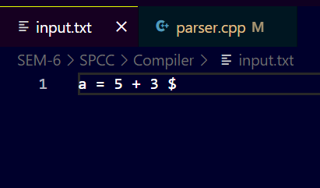

Output :

Accepted=>
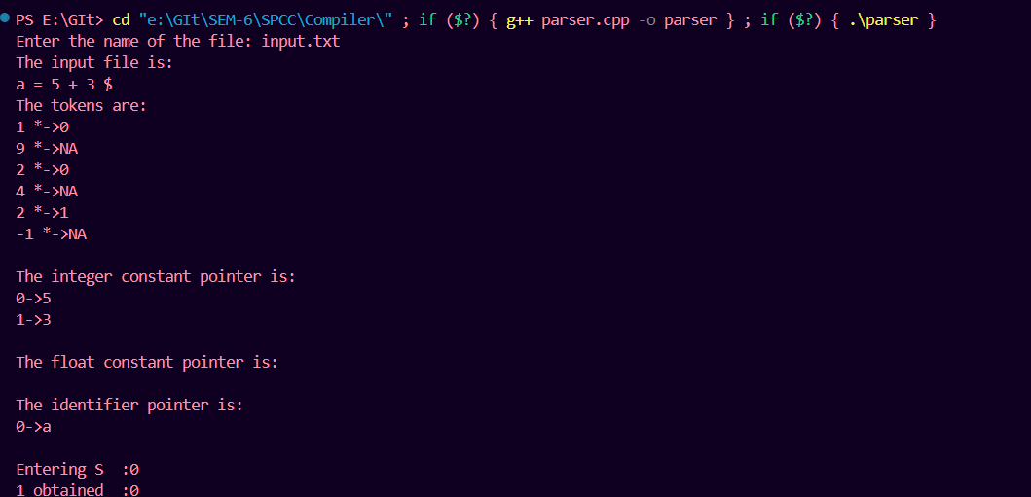

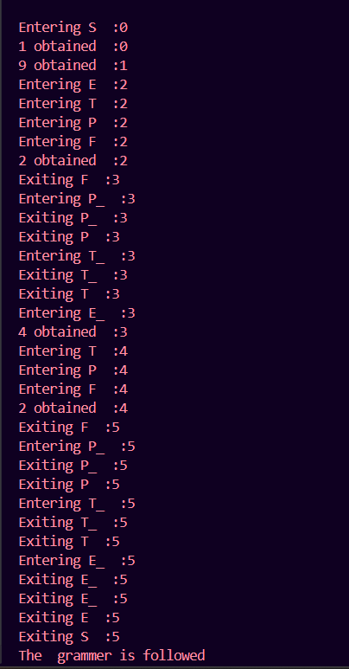

Not Accepted=>
